Ethan Elders

[eelders@my.Athens.edu](mailto:eelders@my.Athens.edu)

00099962

Assignment 1

1. Understanding a program express as English statements:
   1. 36
2. Flowcharts – Shopping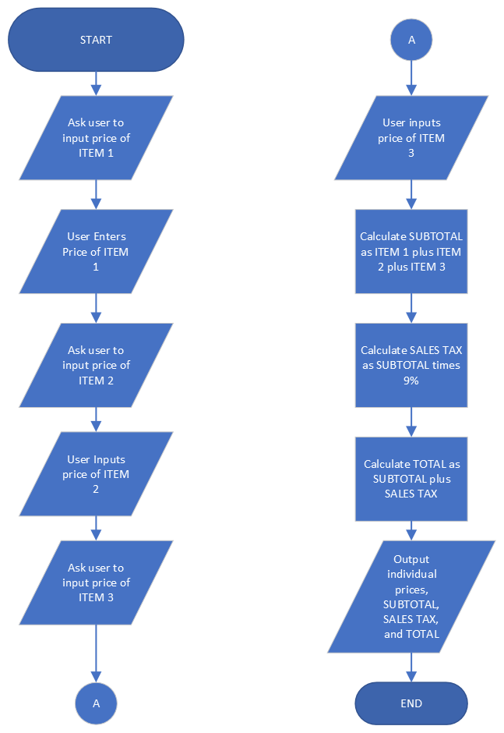
3. Algorithms – Computing an account balance.
   * + 1. Start Program.
       2. Ask the user to enter grades for project Flowchart 1.
       3. Ask the user to enter grades for project Flowchart 2.
       4. Ask the user to enter grades for project Flowchart 3.
       5. Ask the user to enter grades for project Code file 1.
       6. Ask the user to enter grades for project Code file 2.
       7. Ask the user to enter grades for project Code file 3.
4. Pseudocode Algorithm – Golfer’s Game
   1. Ask the user to enter score 1.
   2. score1 = user input.
   3. Ask the user to enter score 2.
   4. score2 = user input.
   5. Ask the user to enter score 3.
   6. score3 = user input.
   7. totalScore = score1 + score2 + score 3.
   8. avgScore = totalScore divided by 3.
   9. Output avgScore.
   10. END.
5. Identify what each of the shapes below represent.
   * + 1. Oval shape starts the program.
       2. Parallelogram 1 displays a prompt to the user asking them to enter two numbers.
       3. Parallelogram 2 provides a line for the user to enter the two numbers.
       4. Rectangle 1 performs the addition of the two numbers entered by the user.
       5. Parallelogram 3 Displays the completed calculation of the two numbers.
       6. Oval shape ends the program.
   1. A problem that would result in the use of this flowchart would be needing to add two total dollar amounts together.
6. Find the error in the Pseudocode.
   1. The pseudocode never allows for the diameter of the pizza to be entered.
   2. The pseudocode performs the calculation of PizzaArea using the value of radius before the value of radius is defined.
7. Diamond Pattern.
   1. 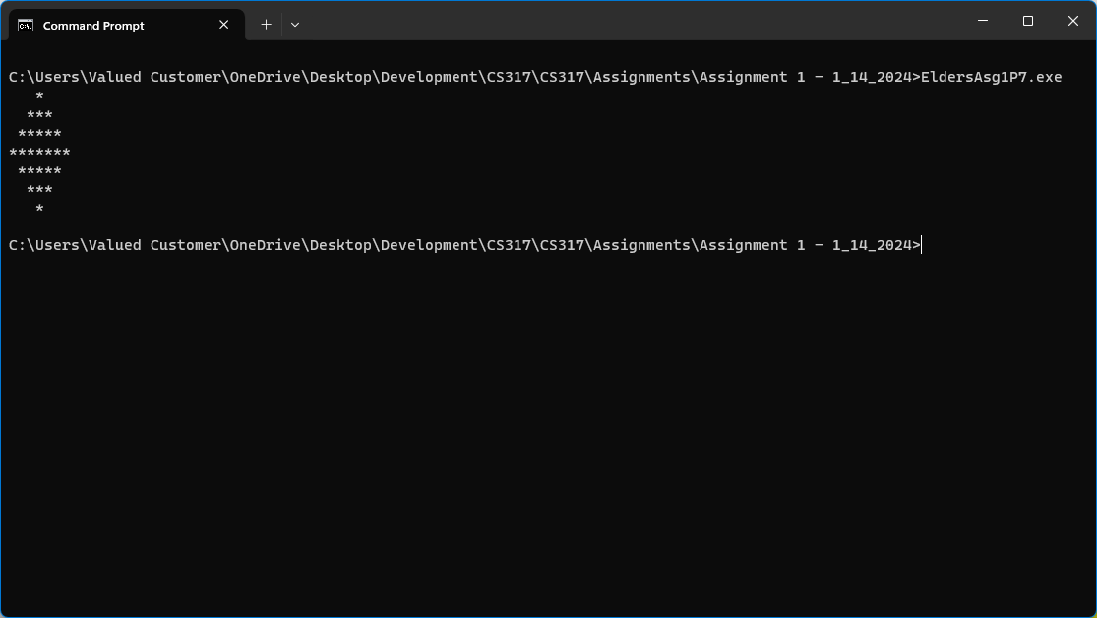
8. Personal Information.
   1. 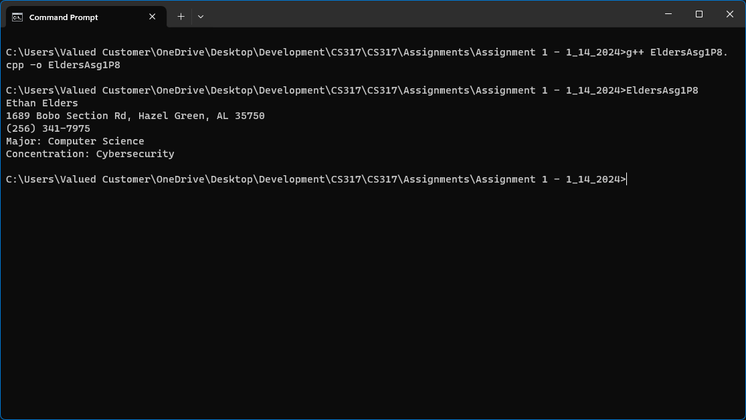
9. Three simple calculations.
   1. 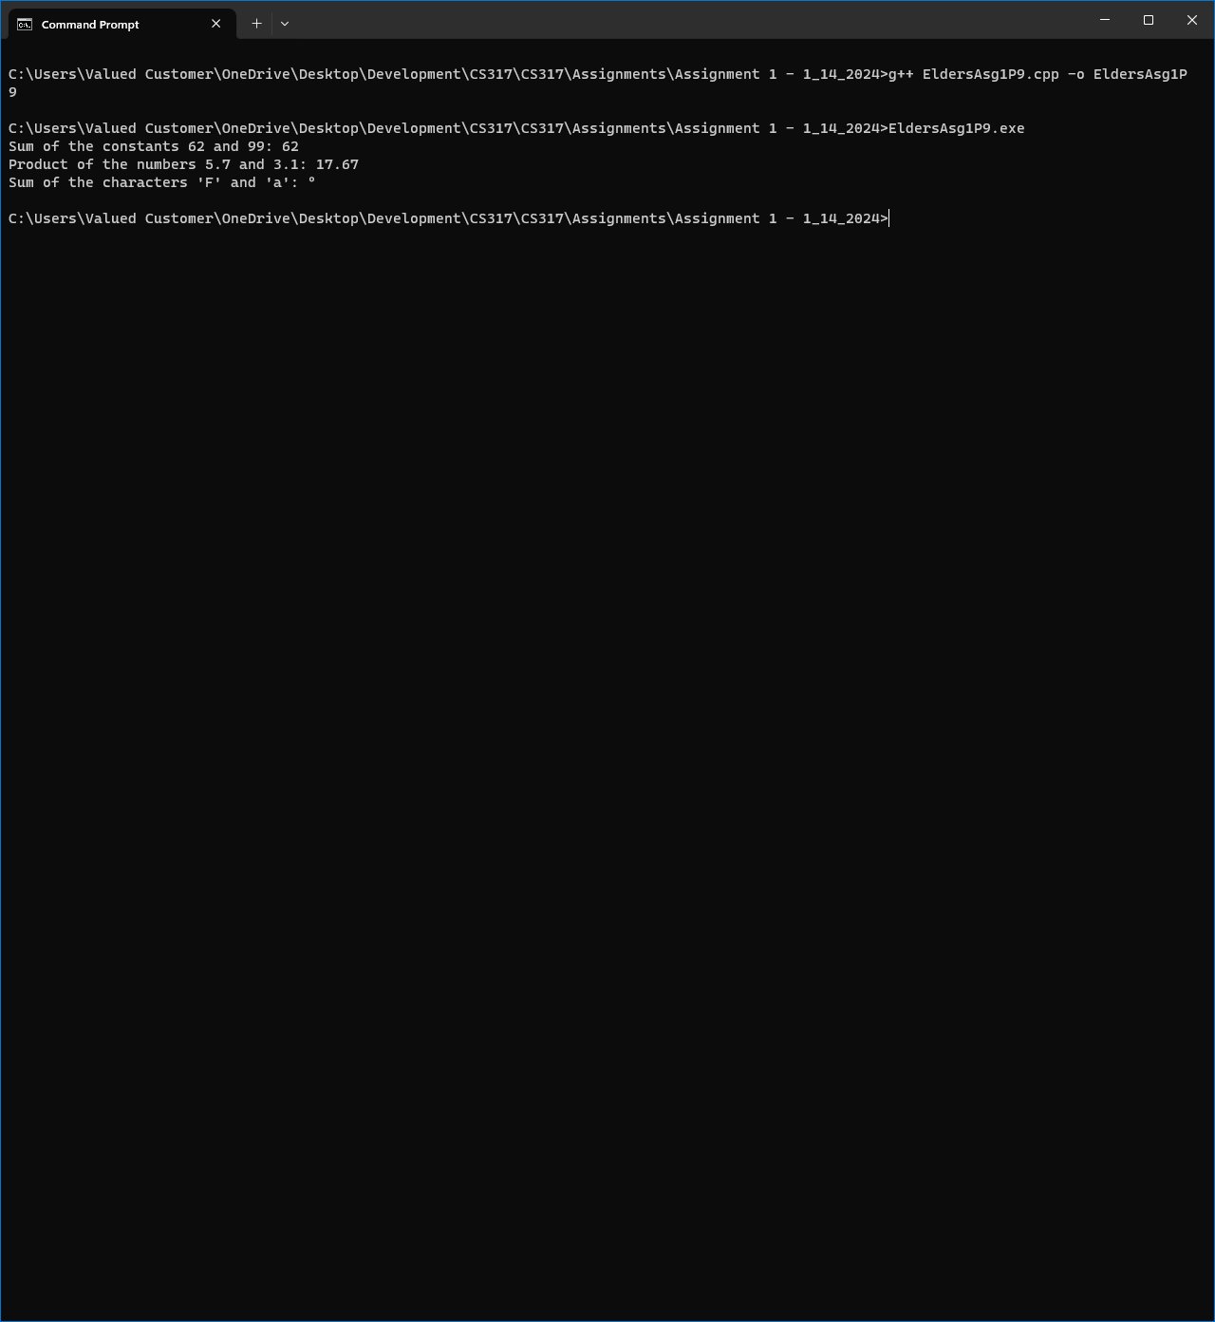
10. Lunches at Burrito Express.
    1. 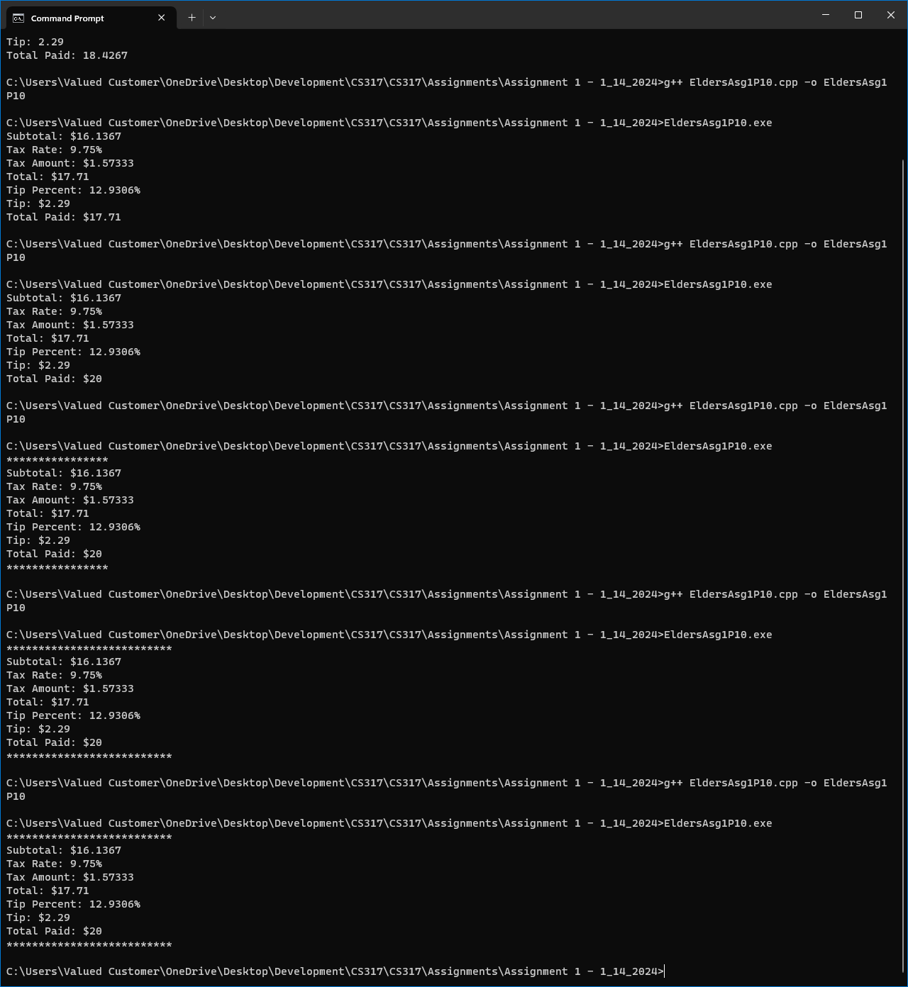
11. Taking away dullness.
    1. 